Лабораторна робота №9

з дисципліни „Об’єктно-орієнтоване програмування”
Проектування класів n та компонент
Мета: Набути навиків створення нащадків класів. Засвоєння принципу ( наслідування( спадковості) в ООП(C#).

Задача 1 Проект «Каток»
Постановка задачі: Розробити програму, після запуску якої на формі з’являється анімоване зображення многокутника: вершини рухаються під кутом в різних напрямках і відбиваються від меж форми.
Лістинг програми

Form1.cs

namespace Katok;

public partial class MainForm : Form
{
public MainForm()
{
InitializeComponent();

TableLayoutPanel layout = new TableLayoutPanel
{
Dock = DockStyle.Fill,
ColumnCount = 2,
RowCount = 2
};

layout.ColumnStyles.Add(new ColumnStyle(SizeType.Percent, 50F));
layout.ColumnStyles.Add(new ColumnStyle(SizeType.Percent, 50F));
layout.RowStyles.Add(new RowStyle(SizeType.Percent, 50F));
layout.RowStyles.Add(new RowStyle(SizeType.Percent, 50F));

Controls.Add(layout);

Random rand = new Random();

for (int i = 0; i < 4; i++)
{
Katok k = new Katok(rand.Next(5, 15));
k.Parent = this;
k.Dock = DockStyle.Fill;
k.BackColor = GetSoftColor(rand);
layout.Controls.Add(k);
}

this.BackColor = GetSoftColor(rand);
}

private Color GetSoftColor(Random rand)
{
int r = rand.Next(100, 200);
int g = rand.Next(100, 200);
int b = rand.Next(100, 200);
return Color.FromArgb(r, g, b);
}
}

Form1.Designer.cs

namespace Katok
{
partial class MainForm
{
private System.ComponentModel.IContainer components = null;

protected override void Dispose(bool disposing)
{
if (disposing && (components != null))
{
components.Dispose();
}
base.Dispose(disposing);
}

#region Windows Form Designer generated code

private void InitializeComponent()
{
this.SuspendLayout();

this.AutoScaleDimensions = new System.Drawing.SizeF(8F, 20F);
this.AutoScaleMode = System.Windows.Forms.AutoScaleMode.Font;
this.ClientSize = new System.Drawing.Size(900, 600);
this.Name = "MainForm";
this.Text = "Yatsiyk Uliana";
this.ResumeLayout(false);
}

#endregion
}
}

UserControl1.cs

using System.Reflection;

namespace Katok;

public partial class Katok : UserControl
{
public Point[] P;
List<Point[]> history = new List<Point[]>();
int[] dx;
int[] dy;
Random R = new Random();
int n;

public Katok(int N)
{
InitializeComponent();
DoubleBuffered = true;

n = N;
P = new Point[n];
dx = new int[n];
dy = new int[n];

for (int i = 0; i < n; i++)
{
P[i].X = R.Next(Width);
P[i].Y = R.Next(Height);

do dx[i] = R.Next(-3, 4); while (dx[i] == 0);
do dy[i] = R.Next(-3, 4); while (dy[i] == 0);
}

timer1.Start();
}

private void timer1_Tick(object sender, EventArgs e)
{
for (int i = 0; i < n; i++)
{
P[i].X += dx[i];
P[i].Y += dy[i];

if (P[i].X < 3 || P[i].X > Width - 3) dx[i] = -dx[i];
if (P[i].Y < 3 || P[i].Y > Height - 3) dy[i] = -dy[i];

P[i].X = Math.Clamp(P[i].X, 3, Width - 3);
P[i].Y = Math.Clamp(P[i].Y, 3, Height - 3);
}

history.Add((Point[])P.Clone());
if (history.Count > 7)
history.RemoveAt(0);

Invalidate();
}

private void Katok_Paint(object sender, PaintEventArgs e)
{
Pen randomPen = new Pen(GetSoftColor(), 2);

foreach (var polygonState in history)
e.Graphics.DrawPolygon(randomPen, polygonState);
}

private Color GetSoftColor()
{
return Color.FromArgb(
150 + R.Next(100),
150 + R.Next(100),
150 + R.Next(100)
);
}

private void Katok_Load(object sender, EventArgs e)
{

}
}

UserControl1.Designer.cs

namespace Katok
{
partial class Katok
{
private System.ComponentModel.IContainer components = null;
private System.Windows.Forms.Timer timer1;

protected override void Dispose(bool disposing)
{
if (disposing && (components != null))
{
components.Dispose();
}
base.Dispose(disposing);
}

#region Component Designer generated code

private void InitializeComponent()
{
components = new System.ComponentModel.Container();
timer1 = new System.Windows.Forms.Timer(components);
SuspendLayout();

timer1.Interval = 20;
timer1.Tick += timer1_Tick;

AutoScaleDimensions = new SizeF(8F, 20F);
AutoScaleMode = AutoScaleMode.Font;
Name = "Katok";
Load += Katok_Load;
Paint += Katok_Paint;
ResumeLayout(false);
}

#endregion
}
}

Результати виконання програми
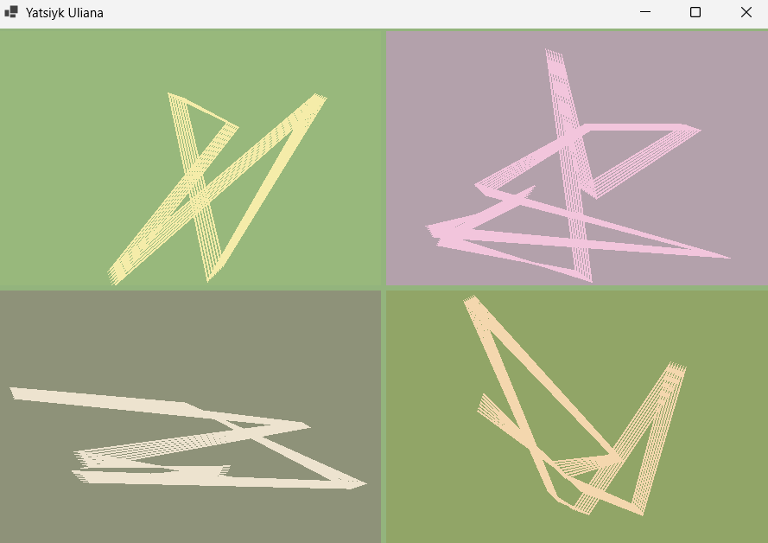

Задача 2 Проект «Редактор візерунків»
Постановка задачі: Розробити програму - редактор візерунків для вишивки хрестиком.
Лістинг програми

Form1.cs
using System;
using System.Windows.Forms;

namespace Stitch
{
public partial class MainForm : Form
{
public MainForm()
{
InitializeComponent();
}

private void buttonColor_Click(object sender, EventArgs e)
{
if (colorDialog1.ShowDialog() == DialogResult.OK)
{
polotno1.ActiveColor = colorDialog1.Color;
}
}

private void RBGoriz_CheckedChanged(object sender, EventArgs e) => polotno1.symm = 2;
private void RBWert_CheckedChanged(object sender, EventArgs e) => polotno1.symm = 1;
private void RBDwi_CheckedChanged(object sender, EventArgs e) => polotno1.symm = 3;
private void RBCentr_CheckedChanged(object sender, EventArgs e) => polotno1.symm = 4;
private void RBNoSym_CheckedChanged(object sender, EventArgs e) => polotno1.symm = 0;

private void buttonClear_Click(object sender, EventArgs e) => polotno1.Clear();

private void btnSave_Click(object sender, EventArgs e)
{
using SaveFileDialog sfd = new SaveFileDialog { Filter = "Stitch Project|*.stitch", DefaultExt = "stitch" };
if (sfd.ShowDialog() == DialogResult.OK)
{
polotno1.SaveToFile(sfd.FileName);
}
}

private void btnLoad_Click(object sender, EventArgs e)
{
using OpenFileDialog ofd = new OpenFileDialog { Filter = "Stitch Project|*.stitch", DefaultExt = "stitch" };
if (ofd.ShowDialog() == DialogResult.OK)
{
polotno1.LoadFromFile(ofd.FileName);
}
}

private void btnImage_Click(object sender, EventArgs e)
{
using SaveFileDialog sfd = new SaveFileDialog { Filter = "PNG Image|*.png|JPEG Image|*.jpg", DefaultExt = "png" };
if (sfd.ShowDialog() == DialogResult.OK)
{
polotno1.SaveAsImage(sfd.FileName);
}
}

private void btnPrint_Click(object sender, EventArgs e)
{
polotno1.PrintPattern();
}

private void chkFill_CheckedChanged(object sender, EventArgs e)
{
polotno1.IsFillMode = chkFill.Checked;
}

private void rbPencil_CheckedChanged(object sender, EventArgs e)
{
if (rbPencil.Checked) polotno1.IsFillMode = false;
}
}
}
Form1.Designer.cs
using System.Windows.Forms;

namespace Stitch
{
partial class MainForm
{
private System.ComponentModel.IContainer components = null;

protected override void Dispose(bool disposing)
{
if (disposing && (components != null)) components.Dispose();
base.Dispose(disposing);
}

#region Windows Form Designer generated code

private void InitializeComponent()
{
this.polotno1 = new Stitch.Polotno();
this.buttonColor = new System.Windows.Forms.Button();
this.buttonClear = new System.Windows.Forms.Button();
this.panel1 = new System.Windows.Forms.Panel();
this.rbPencil = new System.Windows.Forms.CheckBox();
this.chkFill = new System.Windows.Forms.CheckBox();
this.RBNoSym = new System.Windows.Forms.RadioButton();
this.RBCentr = new System.Windows.Forms.RadioButton();
this.RBDwi = new System.Windows.Forms.RadioButton();
this.RBWert = new System.Windows.Forms.RadioButton();
this.RBGoriz = new System.Windows.Forms.RadioButton();
this.labelSym = new System.Windows.Forms.Label();
this.colorDialog1 = new System.Windows.Forms.ColorDialog();
this.btnSave = new System.Windows.Forms.Button();
this.btnLoad = new System.Windows.Forms.Button();
this.btnImage = new System.Windows.Forms.Button();
this.btnPrint = new System.Windows.Forms.Button();
this.panel1.SuspendLayout();
this.SuspendLayout();
//
// polotno1
//
this.polotno1.Location = new System.Drawing.Point(12, 12);
this.polotno1.Name = "polotno1";
this.polotno1.Size = new System.Drawing.Size(620, 426);
this.polotno1.TabIndex = 0;
//
// buttonColor
//
this.buttonColor.Location = new System.Drawing.Point(652, 12);
this.buttonColor.Name = "buttonColor";
this.buttonColor.Size = new System.Drawing.Size(120, 26);
this.buttonColor.TabIndex = 1;
this.buttonColor.Text = "Колір";
this.buttonColor.UseVisualStyleBackColor = true;
this.buttonColor.Click += new System.EventHandler(this.buttonColor_Click);
//
// buttonClear
//
this.buttonClear.Location = new System.Drawing.Point(652, 348);
this.buttonClear.Name = "buttonClear";
this.buttonClear.Size = new System.Drawing.Size(120, 26);
this.buttonClear.TabIndex = 2;
this.buttonClear.Text = "Очистити";
this.buttonClear.UseVisualStyleBackColor = true;
this.buttonClear.Click += new System.EventHandler(this.buttonClear_Click);
//
// panel1
//
this.panel1.Controls.Add(this.rbPencil);
this.panel1.Controls.Add(this.chkFill);
this.panel1.Controls.Add(this.RBNoSym);
this.panel1.Controls.Add(this.RBCentr);
this.panel1.Controls.Add(this.RBDwi);
this.panel1.Controls.Add(this.RBWert);
this.panel1.Controls.Add(this.RBGoriz);
this.panel1.Location = new System.Drawing.Point(652, 68);
this.panel1.Name = "panel1";
this.panel1.Size = new System.Drawing.Size(120, 200);
this.panel1.TabIndex = 3;
//
// rbPencil
//
this.rbPencil.AutoSize = true;
this.rbPencil.Location = new System.Drawing.Point(6, 172);
this.rbPencil.Name = "rbPencil";
this.rbPencil.Size = new System.Drawing.Size(73, 24);
this.rbPencil.TabIndex = 6;
this.rbPencil.Text = "Олівець";
this.rbPencil.UseVisualStyleBackColor = true;
this.rbPencil.CheckedChanged += new System.EventHandler(this.rbPencil_CheckedChanged);
//
// chkFill
//
this.chkFill.AutoSize = true;
this.chkFill.Location = new System.Drawing.Point(6, 145);
this.chkFill.Name = "chkFill";
this.chkFill.Size = new System.Drawing.Size(81, 24);
this.chkFill.TabIndex = 5;
this.chkFill.Text = "Заливка";
this.chkFill.UseVisualStyleBackColor = true;
this.chkFill.CheckedChanged += new System.EventHandler(this.chkFill_CheckedChanged);
//
// RBNoSym
//
this.RBNoSym.AutoSize = true;
this.RBNoSym.Location = new System.Drawing.Point(3, 116);
this.RBNoSym.Name = "RBNoSym";
this.RBNoSym.Size = new System.Drawing.Size(113, 24);
this.RBNoSym.TabIndex = 4;
this.RBNoSym.TabStop = true;
this.RBNoSym.Text = "Без симетрії";
this.RBNoSym.UseVisualStyleBackColor = true;
this.RBNoSym.CheckedChanged += new System.EventHandler(this.RBNoSym_CheckedChanged);
//
// RBCentr
//
this.RBCentr.AutoSize = true;
this.RBCentr.Location = new System.Drawing.Point(3, 87);
this.RBCentr.Name = "RBCentr";
this.RBCentr.Size = new System.Drawing.Size(116, 24);
this.RBCentr.TabIndex = 3;
this.RBCentr.TabStop = true;
this.RBCentr.Text = "Центральна";
this.RBCentr.UseVisualStyleBackColor = true;
this.RBCentr.CheckedChanged += new System.EventHandler(this.RBCentr_CheckedChanged);
//
// RBDwi
//
this.RBDwi.AutoSize = true;
this.RBDwi.Location = new System.Drawing.Point(3, 58);
this.RBDwi.Name = "RBDwi";
this.RBDwi.Size = new System.Drawing.Size(102, 24);
this.RBDwi.TabIndex = 2;
this.RBDwi.TabStop = true;
this.RBDwi.Text = "Дві осі";
this.RBDwi.UseVisualStyleBackColor = true;
this.RBDwi.CheckedChanged += new System.EventHandler(this.RBDwi_CheckedChanged);
//
// RBWert
//
this.RBWert.AutoSize = true;
this.RBWert.Location = new System.Drawing.Point(3, 29);
this.RBWert.Name = "RBWert";
this.RBWert.Size = new System.Drawing.Size(115, 24);
this.RBWert.TabIndex = 1;
this.RBWert.TabStop = true;
this.RBWert.Text = "Вертикальна";
this.RBWert.UseVisualStyleBackColor = true;
this.RBWert.CheckedChanged += new System.EventHandler(this.RBWert_CheckedChanged);
//
// RBGoriz
//
this.RBGoriz.AutoSize = true;
this.RBGoriz.Location = new System.Drawing.Point(3, 0);
this.RBGoriz.Name = "RBGoriz";
this.RBGoriz.Size = new System.Drawing.Size(123, 24);
this.RBGoriz.TabIndex = 0;
this.RBGoriz.TabStop = true;
this.RBGoriz.Text = "Горизонтальна";
this.RBGoriz.UseVisualStyleBackColor = true;
this.RBGoriz.CheckedChanged += new System.EventHandler(this.RBGoriz_CheckedChanged);
//
// labelSym
//
this.labelSym.Location = new System.Drawing.Point(652, 44);
this.labelSym.Name = "labelSym";
this.labelSym.Size = new System.Drawing.Size(120, 21);
this.labelSym.TabIndex = 4;
this.labelSym.Text = "Симетрія";
//
// btnSave
//
this.btnSave.Location = new System.Drawing.Point(652, 380);
this.btnSave.Name = "btnSave";
this.btnSave.Size = new System.Drawing.Size(120, 26);
this.btnSave.TabIndex = 5;
this.btnSave.Text = "Зберегти";
this.btnSave.UseVisualStyleBackColor = true;
this.btnSave.Click += new System.EventHandler(this.btnSave_Click);
//
// btnLoad
//
this.btnLoad.Location = new System.Drawing.Point(652, 412);
this.btnLoad.Name = "btnLoad";
this.btnLoad.Size = new System.Drawing.Size(120, 26);
this.btnLoad.TabIndex = 6;
this.btnLoad.Text = "Завантажити";
this.btnLoad.UseVisualStyleBackColor = true;
this.btnLoad.Click += new System.EventHandler(this.btnLoad_Click);
//
// btnImage
//
this.btnImage.Location = new System.Drawing.Point(652, 444);
this.btnImage.Name = "btnImage";
this.btnImage.Size = new System.Drawing.Size(120, 26);
this.btnImage.TabIndex = 7;
this.btnImage.Text = "Експорт PNG/JPG";
this.btnImage.UseVisualStyleBackColor = true;
this.btnImage.Click += new System.EventHandler(this.btnImage_Click);
//
// btnPrint
//
this.btnPrint.Location = new System.Drawing.Point(652, 476);
this.btnPrint.Name = "btnPrint";
this.btnPrint.Size = new System.Drawing.Size(120, 26);
this.btnPrint.TabIndex = 8;
this.btnPrint.Text = "Друк";
this.btnPrint.UseVisualStyleBackColor = true;
this.btnPrint.Click += new System.EventHandler(this.btnPrint_Click);
//
// MainForm
//
this.ClientSize = new System.Drawing.Size(784, 511);
this.Controls.Add(this.polotno1);
this.Controls.Add(this.buttonColor);
this.Controls.Add(this.buttonClear);
this.Controls.Add(this.panel1);
this.Controls.Add(this.labelSym);
this.Controls.Add(this.btnSave);
this.Controls.Add(this.btnLoad);
this.Controls.Add(this.btnImage);
this.Controls.Add(this.btnPrint);
this.Name = "MainForm";
this.Text = "Редактор візерунків — Stitch";
this.panel1.ResumeLayout(false);
this.panel1.PerformLayout();
this.ResumeLayout(false);
}

#endregion

private Polotno polotno1;
private Button buttonColor;
private Button buttonClear;
private Panel panel1;
private RadioButton RBGoriz;
private RadioButton RBWert;
private RadioButton RBDwi;
private RadioButton RBCentr;
private RadioButton RBNoSym;
private Label labelSym;
private ColorDialog colorDialog1;
private Button btnSave;
private Button btnLoad;
private Button btnImage;
private Button btnPrint;
private CheckBox chkFill;
private CheckBox rbPencil;
}
}
UserControl1.cs
using System;
using System.Collections.Generic;
using System.ComponentModel;
using System.Drawing;
using System.Drawing.Imaging;
using System.Drawing.Printing;
using System.IO;
using System.Linq;
using System.Windows.Forms;

namespace Stitch
{
public partial class Polotno : UserControl
{
public Polotno()
{
InitializeComponent();
DoubleBuffered = true;
ActiveColor = Color.Red;
CrossWidth = 12;
Polotno_SizeChanged(this, EventArgs.Empty);
}

public Color ActiveColor = Color.Red;

private Color[,] Grid;

[Browsable(true)]
[DefaultValue(0)]
public int symm { get; set; }

[Browsable(true)]
[DefaultValue(false)]
public bool IsFillMode { get; set; }

public int CWid, CHig;
public int CrossWidth = 12;

private bool isDrawing = false;
private Point lastCell = Point.Empty;

private void Polotno_MouseDown(object sender, MouseEventArgs e)
{
int cellX = e.X / CrossWidth;
int cellY = e.Y / CrossWidth;

if (cellX < 0 || cellY < 0 || cellX >= CWid || cellY >= CHig) return;

if (IsFillMode && e.Button == MouseButtons.Left)
{
FloodFillCell(cellX, cellY, ActiveColor);
Invalidate();
return;
}

if (e.Button == MouseButtons.Left)
{
isDrawing = true;
lastCell = new Point(cellX, cellY);
ApplySymmetryToCell(cellX, cellY, false);
Invalidate();
}
}

private void Polotno_MouseMove(object sender, MouseEventArgs e)
{
if (!isDrawing) return;

int cellX = e.X / CrossWidth;
int cellY = e.Y / CrossWidth;

if (cellX < 0 || cellY < 0 || cellX >= CWid || cellY >= CHig) return;

if (cellX == lastCell.X && cellY == lastCell.Y) return;

AddLineBetweenCells(lastCell, new Point(cellX, cellY));
lastCell = new Point(cellX, cellY);
Invalidate();
}

private void Polotno_MouseUp_1(object sender, MouseEventArgs e)
{
isDrawing = false;
}

private void ApplySymmetryToCell(int cellX, int cellY, bool isDrag)
{
HandleCell(cellX, cellY, isDrag);

int mx = CWid - 1 - cellX;
int my = CHig - 1 - cellY;

if (symm == 1 || symm == 3)
HandleCell(mx, cellY, isDrag);

if (symm == 2 || symm == 3)
HandleCell(cellX, my, isDrag);

if (symm >= 3 || symm == 4)
HandleCell(mx, my, isDrag);
}

private void HandleCell(int cellX, int cellY, bool isDrag)
{
if (cellX < 0 || cellY < 0 || cellX >= CWid || cellY >= CHig) return;

if (isDrag)
{
SetGridCell(cellX, cellY, ActiveColor);
}
else
{
var cur = GetGridCell(cellX, cellY);
if (cur.ToArgb() == ActiveColor.ToArgb())
SetGridCell(cellX, cellY, Color.Empty);
else
SetGridCell(cellX, cellY, ActiveColor);
}
}

private void AddLineBetweenCells(Point p1, Point p2)
{
int x0 = p1.X, y0 = p1.Y;
int x1 = p2.X, y1 = p2.Y;

int dx = Math.Abs(x1 - x0), sx = x0 < x1 ? 1 : -1;
int dy = Math.Abs(y1 - y0), sy = y0 < y1 ? 1 : -1;
int err = (dx > dy ? dx : -dy) / 2;

while (true)
{
ApplySymmetryToCell(x0, y0, true);

if (x0 == x1 && y0 == y1) break;
int e2 = err;
if (e2 > -dx) { err -= dy; x0 += sx; }
if (e2 < dy) { err += dx; y0 += sy; }
}
}

public void FloodFillCell(int startCellX, int startCellY, Color fillColor)
{
if (startCellX < 0 || startCellY < 0 || startCellX >= CWid || startCellY >= CHig) return;

Color targetColor = GetGridCell(startCellX, startCellY);

if (targetColor.ToArgb() == fillColor.ToArgb()) return;

var startPoints = new HashSet<(int x, int y)>();
startPoints.Add((startCellX, startCellY));
if (symm == 1 || symm == 3) startPoints.Add((CWid - 1 - startCellX, startCellY));
if (symm == 2 || symm == 3) startPoints.Add((startCellX, CHig - 1 - startCellY));
if (symm >= 3 || symm == 4) startPoints.Add((CWid - 1 - startCellX, CHig - 1 - startCellY));

Queue<(int x, int y)> queue = new Queue<(int x, int y)>();
HashSet<(int x, int y)> visited = new HashSet<(int x, int y)>();

foreach (var sp in startPoints)
{
if (sp.x >= 0 && sp.y >= 0 && sp.x < CWid && sp.y < CHig)
{
queue.Enqueue(sp);
visited.Add(sp);
}
}

while (queue.Count > 0)
{
var (cx, cy) = queue.Dequeue();

if (GetGridCell(cx, cy).ToArgb() != targetColor.ToArgb()) continue;

SetCellWithSymmetry(cx, cy, fillColor);

foreach (var (nx, ny) in new[] { (cx - 1, cy), (cx + 1, cy), (cx, cy - 1), (cx, cy + 1) })
{
if (nx >= 0 && ny >= 0 && nx < CWid && ny < CHig && visited.Add((nx, ny)))
{
queue.Enqueue((nx, ny));
}
}
}

Invalidate();
}

private Color GetGridCell(int cellX, int cellY)
{
if (Grid == null) return Color.Empty;
if (cellX < 0 || cellY < 0 || cellX >= CWid || cellY >= CHig) return Color.Empty;
return Grid[cellX, cellY];
}

private void SetGridCell(int cellX, int cellY, Color color)
{
if (Grid == null) return;
if (cellX < 0 || cellY < 0 || cellX >= CWid || cellY >= CHig) return;
Grid[cellX, cellY] = color;
}

private void SetCellWithSymmetry(int cellX, int cellY, Color color)
{
if (cellX < 0 || cellY < 0 || cellX >= CWid || cellY >= CHig) return;

SetGridCell(cellX, cellY, color);

int mx = CWid - 1 - cellX;
int my = CHig - 1 - cellY;

if (symm == 1 || symm == 3) SetGridCell(mx, cellY, color);
if (symm == 2 || symm == 3) SetGridCell(cellX, my, color);
if (symm >= 3 || symm == 4) SetGridCell(mx, my, color);
}

public void SaveToFile(string filename)
{
using StreamWriter sw = new StreamWriter(filename, false);
sw.WriteLine(CrossWidth);
sw.WriteLine(CWid);
sw.WriteLine(CHig);

for (int x = 0; x < CWid; x++)
{
for (int y = 0; y < CHig; y++)
{
var c = GetGridCell(x, y);
if (c.IsEmpty) continue;
sw.WriteLine($"{x},{y},{c.A},{c.R},{c.G},{c.B}");
}
}
}

public void LoadFromFile(string filename)
{
if (!File.Exists(filename)) return;

using StreamReader sr = new StreamReader(filename);
string line = sr.ReadLine();
int cwFromFile = CrossWidth;
if (line != null && int.TryParse(line.Trim(), out int cw)) cwFromFile = cw;

int wid = Math.Max(1, Width / cwFromFile);
int hig = Math.Max(1, Height / cwFromFile);

// другий та третій рядки можуть містити CWid/CHig
string line2 = sr.ReadLine();
string line3 = sr.ReadLine();
if (line2 != null && int.TryParse(line2.Trim(), out int wFromFile))
wid = Math.Max(1, wFromFile);
if (line3 != null && int.TryParse(line3.Trim(), out int hFromFile))
hig = Math.Max(1, hFromFile);

CrossWidth = cwFromFile;
AllocateGrid(wid, hig);

// тепер читаємо точки
string entry;
while ((entry = sr.ReadLine()) != null)
{
var parts = entry.Split(',');
if (parts.Length >= 6)
{
if (int.TryParse(parts[0], out int x) &&
int.TryParse(parts[1], out int y) &&
int.TryParse(parts[2], out int a) &&
int.TryParse(parts[3], out int r) &&
int.TryParse(parts[4], out int g) &&
int.TryParse(parts[5], out int b))
{
if (x >= 0 && y >= 0 && x < CWid && y < CHig)
SetGridCell(x, y, Color.FromArgb(a, r, g, b));
}
}
}

Polotno_SizeChanged(this, EventArgs.Empty);
Invalidate();
}

public void SaveAsImage(string filename)
{
using Bitmap bmp = new Bitmap(Width, Height);
using Graphics g = Graphics.FromImage(bmp);
RenderToGraphics(g);
string ext = Path.GetExtension(filename).ToLowerInvariant();
ImageFormat fmt = ImageFormat.Png;
if (ext == ".jpg" || ext == ".jpeg") fmt = ImageFormat.Jpeg;
else if (ext == ".bmp") fmt = ImageFormat.Bmp;
bmp.Save(filename, fmt);
}

public void PrintPattern()
{
PrintDocument pd = new PrintDocument();
pd.PrintPage += Pd_PrintPage;
pd.Print();
}

private void Pd_PrintPage(object sender, PrintPageEventArgs e)
{
using Bitmap bmp = new Bitmap(Width, Height);
using (Graphics g = Graphics.FromImage(bmp))
{
RenderToGraphics(g);
}

Rectangle bounds = e.MarginBounds;
float scale = Math.Min((float)bounds.Width / bmp.Width, (float)bounds.Height / bmp.Height);
int w = (int)(bmp.Width * scale);
int h = (int)(bmp.Height * scale);
e.Graphics.DrawImage(bmp, bounds.Left, bounds.Top, w, h);
e.HasMorePages = false;
}

private void RenderToGraphics(Graphics g)
{
g.Clear(Color.White);

using (Pen p = new Pen(Color.FromArgb(40, Color.Gray)))
{
for (int x = 0; x <= Width; x += CrossWidth) g.DrawLine(p, x, 0, x, Height);
for (int y = 0; y <= Height; y += CrossWidth) g.DrawLine(p, 0, y, Width, y);
}

if (Grid == null) return;

for (int ix = 0; ix < CWid; ix++)
{
for (int iy = 0; iy < CHig; iy++)
{
var c = Grid[ix, iy];
if (c.IsEmpty) continue;
using (SolidBrush b = new SolidBrush(c))
{
int px = ix * CrossWidth;
int py = iy * CrossWidth;
g.FillRectangle(b, px, py, CrossWidth - 1, CrossWidth - 1);
}
}
}
}

private void Polotno_Paint(object sender, PaintEventArgs e)
{
RenderToGraphics(e.Graphics);
}

public void Clear()
{
if (Grid == null) return;
for (int x = 0; x < CWid; x++)
for (int y = 0; y < CHig; y++)
Grid[x, y] = Color.Empty;
Invalidate();
}

private void Polotno_SizeChanged(object sender, EventArgs e)
{
int newCWid = Math.Max(1, Width / CrossWidth);
int newCHig = Math.Max(1, Height / CrossWidth);
AllocateGrid(newCWid, newCHig);
Invalidate();
}

private void AllocateGrid(int newCWid, int newCHig)
{
Color[,] old = Grid;
int oldW = CWid, oldH = CHig;

CWid = newCWid;
CHig = newCHig;
Grid = new Color[CWid, CHig];

for (int x = 0; x < CWid; x++)
for (int y = 0; y < CHig; y++)
Grid[x, y] = Color.Empty;

if (old != null)
{
int minW = Math.Min(oldW, CWid);
int minH = Math.Min(oldH, CHig);
for (int x = 0; x < minW; x++)
for (int y = 0; y < minH; y++)
Grid[x, y] = old[x, y];
}
}
}
}
UserControl1.Designer.cs
using System.ComponentModel;

namespace Stitch
{
partial class Polotno
{
private IContainer components = null;

protected override void Dispose(bool disposing)
{
if (disposing) components?.Dispose();
base.Dispose(disposing);
}

#region Component Designer generated code

private void InitializeComponent()
{
this.components = new Container();
this.SuspendLayout();
//
// Polotno
//
this.AutoScaleMode = System.Windows.Forms.AutoScaleMode.Font;
this.Name = "Polotno";
this.Size = new System.Drawing.Size(620, 426);
this.Paint += new System.Windows.Forms.PaintEventHandler(this.Polotno_Paint);
this.MouseDown += new System.Windows.Forms.MouseEventHandler(this.Polotno_MouseDown);
this.MouseMove += new System.Windows.Forms.MouseEventHandler(this.Polotno_MouseMove);
this.MouseUp += new System.Windows.Forms.MouseEventHandler(this.Polotno_MouseUp_1);
this.SizeChanged += new System.EventHandler(this.Polotno_SizeChanged);
this.ResumeLayout(false);
}

#endregion
}
}
Результати виконання програми

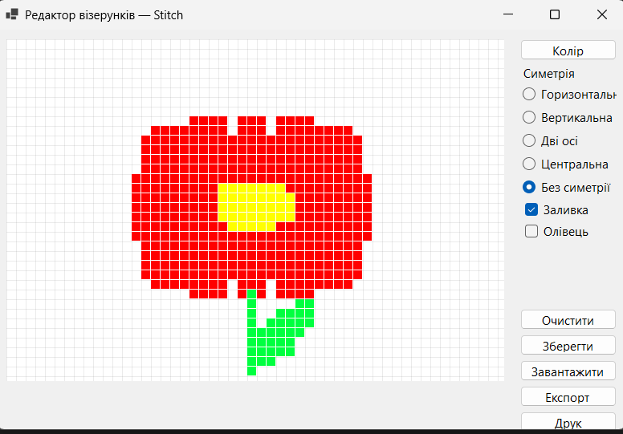

Задача 3 Проект «Хрестики-нулики»
Постановка задачі: Розробити програму для гри з комп’ютером у хрестики-нулики.
Лістинг програми

Form1.cs
using System;
using System.Drawing;
using System.Windows.Forms;
using System.Xml.Linq;

public partial class Form1 : Form
{
private int CrossWins = 0, ZeroWins = 0, Draws = 0;
private string PlayerName = "Гравець";

public Form1()
{
InitializeComponent();
this.Text = "Хрестики-нулики";
this.StartPosition = FormStartPosition.CenterScreen;
this.Size = new Size(520, 600);

pole1.OnFinish += Pole_OnFinish;
pole1.OnDraw += Pole_OnDraw;
btnStart.Click += BtnStart_Click;

UpdateScore();
btnStart.Enabled = false;
}

private void Pole_OnDraw()
{
Draws++;
lblDraws.Text = Draws.ToString();
btnStart.Text = "Нічия!";
btnStart.ForeColor = Color.Blue;
btnStart.Enabled = true;
}

private void Pole_OnFinish(char winner)
{
if (winner == 'X') CrossWins++;
else ZeroWins++;

lblPlayerScore.Text = CrossWins.ToString();
lblComputerScore.Text = ZeroWins.ToString();

if (winner == 'X')
{
btnStart.Text = "Вітаю!";
btnStart.ForeColor = Color.Red;
}
else
{
btnStart.Text = "Комп'ютер переміг";
btnStart.ForeColor = Color.Navy;
}

btnStart.Enabled = true;
UpdateScore();
}

private void BtnStart_Click(object sender, EventArgs e)
{
pole1.Clear();
btnStart.Text = "Почати";
btnStart.ForeColor = Color.Black;
btnStart.Enabled = false;
}

private void UpdateScore()
{
lblPlayerName.Text = PlayerName;
lblPlayerScore.Text = CrossWins.ToString();
lblComputerScore.Text = ZeroWins.ToString();
lblDraws.Text = Draws.ToString();

lblPlayerName.Font = lblPlayerScore.Font = new Font("Segoe UI", 12, FontStyle.Regular);
lblComputerScore.Font = new Font("Segoe UI", 12, FontStyle.Regular);
lblPlayerName.ForeColor = lblPlayerScore.ForeColor = Color.Black;
lblComputerScore.ForeColor = Color.Black;

if (CrossWins > ZeroWins)
{
lblPlayerName.ForeColor = lblPlayerScore.ForeColor = Color.Red;
lblPlayerName.Font = lblPlayerScore.Font = new Font("Segoe UI", 12, FontStyle.Bold);
}
else if (ZeroWins > CrossWins)
{
lblComputerScore.ForeColor = Color.Red;
lblComputerScore.Font = new Font("Segoe UI", 12, FontStyle.Bold);
}
}

private void txtName_TextChanged(object sender, EventArgs e)
{
PlayerName = txtName.Text.Trim();
if (string.IsNullOrEmpty(PlayerName)) PlayerName = "Гравець";
lblPlayerName.Text = PlayerName;
}

private void radioBeginner_CheckedChanged(object sender, EventArgs e) { if (radioBeginner.Checked) pole1.ComputerLevel = Level.Beginner; }
private void radioCandidate_CheckedChanged(object sender, EventArgs e) { if (radioCandidate.Checked) pole1.ComputerLevel = Level.Candidate; }
private void radioExpert_CheckedChanged(object sender, EventArgs e) { if (radioExpert.Checked) pole1.ComputerLevel = Level.Expert; }
}
Form1.Designer.cs
partial class Form1
{
private System.ComponentModel.IContainer components = null;

protected override void Dispose(bool disposing)
{
if (disposing && (components != null)) components.Dispose();
base.Dispose(disposing);
}

private Pole pole1;
private Button btnStart;
private Label lblPlayerName;
private Label lblPlayerScore;
private Label lblComputerScore;
private Label lblDraws;
private TextBox txtName;
private RadioButton radioBeginner;
private RadioButton radioCandidate;
private RadioButton radioExpert;
private GroupBox groupBox1;

private void InitializeComponent()
{
this.pole1 = new Pole();
this.btnStart = new Button();
this.lblPlayerName = new Label();
this.lblPlayerScore = new Label();
this.lblComputerScore = new Label();
this.lblDraws = new Label();
this.txtName = new TextBox();
this.radioBeginner = new RadioButton();
this.radioCandidate = new RadioButton();
this.radioExpert = new RadioButton();
this.groupBox1 = new GroupBox();

this.groupBox1.SuspendLayout();
this.SuspendLayout();

// pole1
this.pole1.Location = new Point(30, 30);
this.pole1.Size = new Size(340, 340);

// btnStart
this.btnStart.Location = new Point(400, 120);
this.btnStart.Size = new Size(90, 50);
this.btnStart.Text = "Почати";
this.btnStart.Font = new Font("Segoe UI", 12F, FontStyle.Bold);
this.btnStart.UseVisualStyleBackColor = true;

// Елементи статистики
this.lblPlayerName.AutoSize = true;
this.lblPlayerName.Location = new Point(50, 400);
this.lblPlayerName.Font = new Font("Segoe UI", 14F, FontStyle.Bold);
this.lblPlayerName.Text = "Гравець";

this.lblPlayerScore.AutoSize = true;
this.lblPlayerScore.Location = new Point(180, 400);
this.lblPlayerScore.Font = new Font("Segoe UI", 14F);
this.lblPlayerScore.Text = "0";

this.lblComputerScore.AutoSize = true;
this.lblComputerScore.Location = new Point(300, 400);
this.lblComputerScore.Font = new Font("Segoe UI", 14F);
this.lblComputerScore.Text = "0";

this.lblDraws.AutoSize = true;
this.lblDraws.Location = new Point(420, 400);
this.lblDraws.Font = new Font("Segoe UI", 12F);
this.lblDraws.Text = "0";

this.txtName.Location = new Point(50, 440);
this.txtName.Size = new Size(200, 25);
this.txtName.Text = "Гравець";
this.txtName.TextChanged += txtName_TextChanged;

// Група рівнів
this.groupBox1.Location = new Point(30, 480);
this.groupBox1.Size = new Size(460, 70);
this.groupBox1.Text = "Рівень комп'ютера";
this.groupBox1.Controls.Add(this.radioBeginner);
this.groupBox1.Controls.Add(this.radioCandidate);
this.groupBox1.Controls.Add(this.radioExpert);

this.radioBeginner.Location = new Point(20, 30);
this.radioBeginner.Text = "Початківець";
this.radioCandidate.Location = new Point(160, 30);
this.radioCandidate.Text = "Кандидат";
this.radioCandidate.Checked = true;
this.radioExpert.Location = new Point(300, 30);
this.radioExpert.Text = "Експерт";

this.radioBeginner.CheckedChanged += radioBeginner_CheckedChanged;
this.radioCandidate.CheckedChanged += radioCandidate_CheckedChanged;
this.radioExpert.CheckedChanged += radioExpert_CheckedChanged;

// Додати все на форму
this.Controls.Add(this.pole1);
this.Controls.Add(this.btnStart);
this.Controls.Add(this.lblPlayerName);
this.Controls.Add(this.lblPlayerScore);
this.Controls.Add(this.lblComputerScore);
this.Controls.Add(this.lblDraws);
this.Controls.Add(this.txtName);
this.Controls.Add(this.groupBox1);

// Підписи
var lblVs = new Label() { Text = ":", Location = new Point(240, 400), AutoSize = true, Font = new Font("Segoe UI", 14F) };
var lblComp = new Label() { Text = "Комп'ютер", Location = new Point(270, 400), AutoSize = true, Font = new Font("Segoe UI", 12F) };
var lblDrawCaption = new Label() { Text = "Нічії:", Location = new Point(370, 400), AutoSize = true, Font = new Font("Segoe UI", 12F) };
this.Controls.AddRange(new Control[] { lblVs, lblComp, lblDrawCaption });

this.groupBox1.ResumeLayout(false);
this.ResumeLayout(false);
this.PerformLayout();
}
}
UserControl1.cs
using System;
using System.Drawing;
using System.Windows.Forms;
using System.ComponentModel;

public delegate void FinishEventHandler(char winner);

public enum Level { Beginner, Candidate, Expert }

public partial class Pole : UserControl
{
private GameButton[,] P = new GameButton[3, 3];
public event FinishEventHandler OnFinish;
public event Action OnDraw;

private bool active = true;
private int Moves = 0;
[DesignerSerializationVisibility(DesignerSerializationVisibility.Hidden)]
public Level ComputerLevel { get; set; } = Level.Expert;

public Pole()
{
this.DoubleBuffered = true;
this.Resize += Pole_Resize;

for (int r = 0; r < 3; r++)
for (int c = 0; c < 3; c++)
{
P[r, c] = new GameButton();
P[r, c].Click += GameButton_Click;
this.Controls.Add(P[r, c]);
}

ArrangeButtons();
}

private void Pole_Resize(object sender, EventArgs e) => ArrangeButtons();

private void ArrangeButtons()
{
int w = this.ClientSize.Width / 3;
int h = this.ClientSize.Height / 3;
for (int r = 0; r < 3; r++)
for (int c = 0; c < 3; c++)
{
P[r, c].Left = c * w;
P[r, c].Top = r * h;
P[r, c].Width = w;
P[r, c].Height = h;
}
}

public void Clear()
{
for (int r = 0; r < 3; r++)
for (int c = 0; c < 3; c++)
P[r, c].SetClear();
active = true;
Moves = 0;
}

private void GameButton_Click(object sender, EventArgs e)
{
var btn = (GameButton)sender;
if (!btn.IsClear || !active) return;

btn.SetCross();
Moves++;
CheckWin();
if (!active) return;

if (Moves >= 9)
{
active = false;
OnDraw?.Invoke();
return;
}

ComputerMove();
}

private void ComputerMove()
{
if (ComputerLevel == Level.Beginner)
{
RandomMove();
return;
}

// Спроба виграти (O)
var win = FindBestMove('O');
if (win != null)
{
P[win.Value.r, win.Value.c].SetZero();
Moves++;
CheckWin();
return;
}

// Експерт: блокуємо виграш гравця
if (ComputerLevel == Level.Expert)
{
var block = FindBestMove('X');
if (block != null)
{
P[block.Value.r, block.Value.c].SetZero();
Moves++;
CheckWin();
return;
}
}

// Інакше випадково
RandomMove();
}

private void RandomMove()
{
Random rnd = new Random();
int r, c;
do
{
r = rnd.Next(3);
c = rnd.Next(3);
} while (!P[r, c].IsClear);

P[r, c].SetZero();
Moves++;
CheckWin();
}

private (int r, int c)? FindBestMove(char symbol)
{
bool isCross = symbol == 'X';
for (int r = 0; r < 3; r++)
for (int c = 0; c < 3; c++)
if (P[r, c].IsClear)
{
if (isCross) P[r, c].TempSetCross();
else P[r, c].TempSetZero();

if (CheckWinSymbol(symbol))
{
if (isCross) P[r, c].TempClearCross();
else P[r, c].TempClearZero();
return (r, c);
}

if (isCross) P[r, c].TempClearCross();
else P[r, c].TempClearZero();
}
return null;
}

private void CheckWin()
{
var lines = new int[][]
{
new int[] {0,0,0,1,0,2}, new int[] {1,0,1,1,1,2}, new int[] {2,0,2,1,2,2},
new int[] {0,0,1,0,2,0}, new int[] {0,1,1,1,2,1}, new int[] {0,2,1,2,2,2},
new int[] {0,0,1,1,2,2}, new int[] {0,2,1,1,2,0}
};

foreach (var l in lines)
{
int r0 = l[0], c0 = l[1], r1 = l[2], c1 = l[3], r2 = l[4], c2 = l[5];

if (P[r0, c0].IsCross && P[r1, c1].IsCross && P[r2, c2].IsCross)
{
HighlightLine(r0, c0, r1, c1, r2, c2);
active = false;
OnFinish?.Invoke('X');
return;
}
if (P[r0, c0].IsZero && P[r1, c1].IsZero && P[r2, c2].IsZero)
{
HighlightLine(r0, c0, r1, c1, r2, c2);
active = false;
OnFinish?.Invoke('O');
return;
}
}
}

private bool CheckWinSymbol(char symbol)
{
bool cross = symbol == 'X';
Func<int, int, bool> cell = (r, c) => cross ? P[r, c].IsCross : P[r, c].IsZero;

for (int i = 0; i < 3; i++)
if ((cell(i, 0) && cell(i, 1) && cell(i, 2)) ||
(cell(0, i) && cell(1, i) && cell(2, i))) return true;
return (cell(0, 0) && cell(1, 1) && cell(2, 2)) ||
(cell(0, 2) && cell(1, 1) && cell(2, 0));
}

private void HighlightLine(int r0, int c0, int r1, int c1, int r2, int c2)
{
P[r0, c0].HighlightWin();
P[r1, c1].HighlightWin();
P[r2, c2].HighlightWin();
}
}
UserControl1.Designer.cs
partial class Pole
{
private System.ComponentModel.IContainer components = null;

protected override void Dispose(bool disposing)
{
if (disposing && (components != null))
components.Dispose();
base.Dispose(disposing);
}

private void InitializeComponent()
{
this.SuspendLayout();
this.AutoScaleMode = System.Windows.Forms.AutoScaleMode.Font;
this.BackColor = System.Drawing.Color.DarkGray;
this.Name = "Pole";
this.Size = new System.Drawing.Size(300, 300);
this.ResumeLayout(false);
}
}
Результати виконання програми
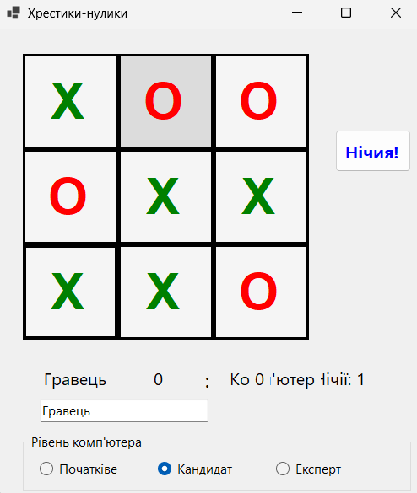
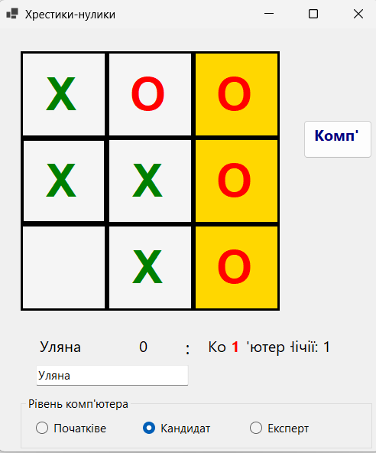

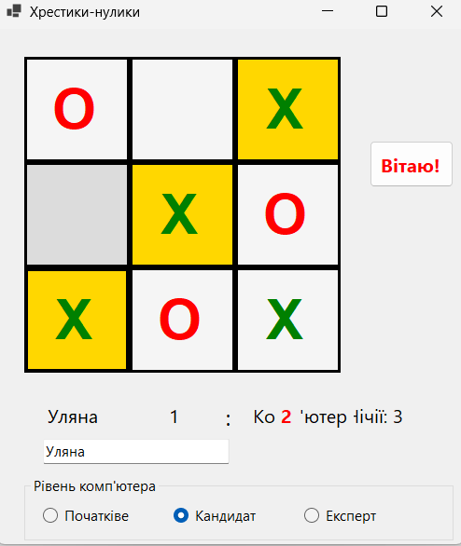

Висновок: Набути навиків створення нащадків класів. Засвоєння принципу ( наслідування( спадковості) в ООП(C#).

